
SHIRE HIGHLANDS EDUCATION DIVISION
2026 MALAWI SCHOOL CERTIFICATE OF EDUCATION MOCK
EXAMINATION

WOODWORK

Paper I
Theory and Design
(100 marks)
Tuesday, 10 March Time Allowed: 2hrs 45 min
1:00-3:45 pm

Question number | Tick if answered | Do not write in these columns
1

2

3

4

5

6

7

8

9

10

TOTAL
Instructions
1. This paper contains 11 pages. Please check.

2. Answer all questions in Sections A and C, and any two questions in Section B.

3. The maximum number of marks for each answer is indicated against each question.

4. Make sketches to illustrate your answers
wherever possible.

5. Candidates are allowed 5 minutes at the beginning of the examination to read through the paper.

6. Questions in Section C to be answered on A3 drawing sheets provided.

7. Write your Name at the top of the page.

Section A (30 marks)
Answer all the five questions in this section.
- a. What is the difference between case hardening from a check in timber?
____________________________________________________________________________________________________________________________________________________________________________________________________________________________________________________________________________________________________________
(2 marks)
b. Figure 1 shows two types of timber defects A and B.

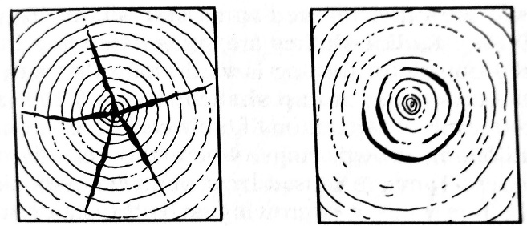
A B
Figure 1

- Name the type of timber defects A and B.
A __________________________________________________________________
B __________________________________________________________________
(2 marks)
- Give the cause of timber defect B.
_____________________________________________________________________
_____________________________________________________________________
(1 mark)
c. State one disadvantage of preserving timber by spraying or brushing.
______________________________________________________________________________________________________________________________________________________
(1 mark)
2. a. Define the following terms as used in woodwork:
(i) fixed assets
__________________________________________________________________________________________________________________________________________
(1 mark)
(ii) current assets
__________________________________________________________________________________________________________________________________________
(1 mark)
b. Give one example of each of the terms in 2 (a).
(i) fixed assets
____________________________________________________________________
(1 mark)
(ii) current assets
____________________________________________________________________
(1 mark)
c. (i) Why is motivation of workers important? ___________________________________________________________________
___________________________________________________________________ (1 mark)
(ii) Give one advantage of preparing a cutting list in furniture production.
___________________________________________________________________
(1 mark)
3. a. (i) Define shearing strength as a mechanical property of timber.
___________________________________________________________________
___________________________________________________________________
(1 mark)
(ii) Give one example in woodwork where shearing strength could be applied.
___________________________________________________________________
(1 mark)

b. Figure 2 is showing a roof structure and alignment of forces in beams of timber.

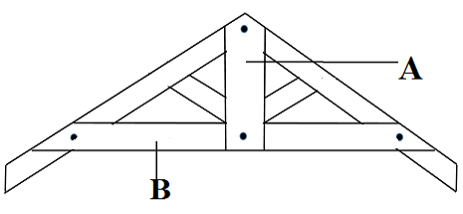
Figure 2
(i) Identify forces operating in beams A and B.
A ________________________________________________________________
B ________________________________________________________________
(2 marks)
(ii) Using arrows, indicate on the diagram the direction of forces acting in beam B. (1 mark)
- State how presence of knots in beam B could weaken its stability.
__________________________________________________________________
(1 mark)
4. a. Describe any two practices that should be done to prolong life of hand tools in the workshop.
______________________________________________________________________________________________________________________________________________________
(2 marks)
b. Define the following processes carried out on a dimension circular saw:
- ripping
______________________________________________________________________________________________________________________________________
(1 mark)
(ii) chamfering
______________________________________________________________________________________________________________________________________
(1 mark)
c. Differentiate the use of each of the following special curve-cutting saws:

- coping saw
______________________________________________________________________________________________________________________________________
(1 mark)
- bow saw
______________________________________________________________________________________________________________________________________
(1 mark)
5. a State one advantage of portable power tools over machine tools.
_________________________________________________________________________
_________________________________________________________________________ (1 mark)

b. Figure 3 is a machine tool used in the woodwork workshop. 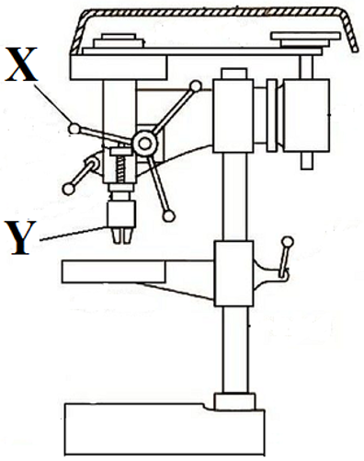
Figure 3
- Give the name and function of the machine shown in Figure 3.
Name: _______________________________________________________
Function: _______________________________________________________
(2 marks)

- Name parts labelled X and Y
X _____________________________________________________________
Y _____________________________________________________________
(2 marks)
- State any one safety precautions to be observed when working on the machine shown in Figure 3.
___________________________________________________________________
___________________________________________________________________
(1 mark)

Section B (30 marks)
Answer any two questions from this section
6. Figure 4 below shows the common types of hinges.
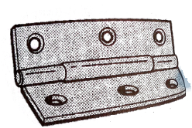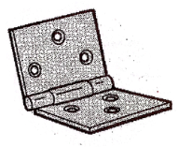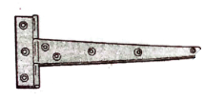
A B C
Figure 4
- Name the type of hinges labelled A and B.
___________________________________________________________________________________________________________________________________________ (2 marks)
b. Give any one use of hinges labelled C.
_________________________________________________________________________
(1 mark)
c. Give any two common locks that are used on doors and windows of houses.
______________________________________________________________________________________________________________________________________________________
(2 marks)
d. Define the following terms as used in roofing.
i. Rise: ____________________________________________________________________
ii span: ____________________________________________________________________
(2 marks)
e. With aid of sketches, describe how a rim lock can be fitted into a door.

___________________________________________________________________________________________________________________________________________________________________________________________________________________________________________________________________________________________________________________________________________________________________________________________________________________________________________________________________________________________________________________________________________________________________________________________________________________________________________________________________________________________________
(8 marks)
7. a. A freshly cut piece of timber weighs 31.5g. When thoroughly dried in an oven, it weighs 23.6g. Work out percentage moisture content of the timber.

(3 marks)
b. How does unseasoned timber affect the following:

(i) transportation of timber
___________________________________________________________________
___________________________________________________________________
(1 mark)
(ii) finishes and adhesives
______________________________________________________________________________________________________________________________________
(1 mark)
(iii) nails and screws used as fasteners
___________________________________________________________________
___________________________________________________________________
(1 mark)

c. (i) Why is primer coat necessary in finishing woodwork products?
___________________________________________________________________
___________________________________________________________________
(1 mark)
(ii) Write down three steps to be followed when applying initial three coats of varnish to a piece of wood product.
___________________________________________________________________
___________________________________________________________________
___________________________________________________________________
(3 marks)
d. State any three characteristics of polyvinyl acetate (PVA) glue.

_________________________________________________________________________________________________________________________________________________________________________________________________________________________________
(3 marks)
e. Differentiate the functions of ‘catches’ and ‘stays’ when fitted to lids of boxes.
______________________________________________________________________________________________________________________________________________________
(2 marks)

8. Figure 5 shows a piece of timber to be marked and cut as shown:
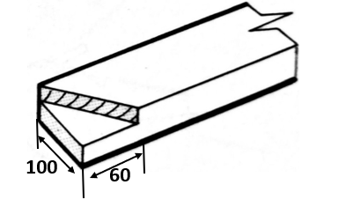
Figure 5
a. State how you would use the following tools on the piece of timber:

(i) try square
__________________________________________________________________________________________________________________________________________
(1 mark)
(ii) marking gauge
__________________________________________________________________________________________________________________________________________
(1 mark)
(iii) bevel square
__________________________________________________________________________________________________________________________________________
(1 mark)
(iv) cross-cut saw
__________________________________________________________________________________________________________________________________________
(1 mark)
b. Mention any three ways of reinforcing woodwork joints.
_________________________________________________________________________________________________________________________________________________________________________________________________________________________________
(3 marks)

c. (i) State any two factors to consider when selecting upholstery materials.
__________________________________________________________________________________________________________________________________________
(2 marks)
(ii) Give any three advantages and three disadvantages of a flat roof.
Advantages:
_______________________________________________________________________________________________________________________________________________________________________________________________________________
(3 marks)
Disadvantages:
_______________________________________________________________________________________________________________________________________________________________________________________________________________
(3 marks)

SECTION C (40 MARKS)
Answer both questions in this section on an A3 paper provided.
Use the following information to answer questions 9 and 10.
Students have a challenge of safe keeping of hand tools in the workshop.
Design a HAND TOOL SHELF that can safely keep hand tools. The design should fulfil the following:
- It must be movable.
- One compartment be lockable.
- Strong, attractive and durable.
- 1200mm x 800mm x 350mm in size.
9. a. Make outlined sketches to show your two ideas of the HAND TOOLSHELF.
(10marks)
b. Select the best design and produce its cutting list (5marks)
- materials.
- Sizes.
- types of finish.
- number of parts required.
c. Draw an ISOMETRIC EXPLODED VIEW to a suitable scale, of any one joint to be used in your construction. (5marks)
10. Using the best design chosen, draw the following views to a suitable scale in either first angle or third angle orthographic projection:
a. A front elevation of the HAND TOOL SHELF. (8marks)
b. An end elevation from the left view. (6marks)
c. Insert three main dimensions. (3marks)
d. Indicate the
- scale used. (1mark)
- symbol of projection used (2marks)
END OF QUESTION PAPER

